 

eIDEAS Project Documentation

University of Regina  
Dr. Tim Maciag

May 23, 2018

# Authors names:

Malkiat Singh, Mhd Salim Bakri, Mohamed Aly **CONTENTS**

**Authors names:** **1**

**INTRODUCTION** **3**

Purpose 3

Scope 3

Background 3

References 4

Assumptions and Constraints 4

Constraints 4

Document Overview 5

**METHODOLOGY** **5**

**FUNCTIONAL REQUIREMENTS** **5**

Context Diagram 5

User Requirements 5

Data Flow Diagrams 7

Logical Data Model/Data Dictionary 8

Specification Requirements 8

**OTHER REQUIREMENTS** **9**

Interface Requirements 9

Hardware Interfaces 9

Software Interfaces 9

Data Conversion Requirements 10

Hardware/Software Requirements 10

Operational Requirements 10

Security and Privacy 10

Audit Trail 10

Reliability 10

Recoverability 10

System Availability 11

General Performance 11

Data Retention 11

# INTRODUCTION

## **Purpose**

The purpose of this document is to describe in details the system proposed to be implemented to address the eHealth need for a system which can gather the employees ideas, sort it, follow it up through the whole process, enable interaction between employees on departement level as well as on organization level.

## **Scope**

This document describes the system functionality, describing the methodology applied in details, detailing the functional requirements, mentioning each interface, its links, menus, pop up menus and icons.

## **Background**

eHealth Saskatchewan (eHS) is a Treasury Board Crown within the province of Saskatchewan providing Information Technology (IT) support to Saskatchewan’s health sector. Through the vision “Empower Patients. Enable Care,” eHS has a goal and purpose to improve the quality of health care across the province for both patients and health care providers. In the organization’s ongoing effort to achieve this goal and purpose, eHS focuses on the sustainability of their services by fostering an internal culture of innovation. In operationalizing a culture of innovation, eHS employees are encouraged to individually and collaboratively trial new ideas and innovations through Plan, Do, Check, Act (PDCA) cycles with the goal of improving quality, cost, delivery, safety, and engagement within eHS.

A tool was developed called Challenge 100 which unfortunately didn’t succeed in fulfilling the goals it has been design for, where many deficiencies are reported which hundred reaching the ultimate goal.

An initiative has been taken to re-brand the tool to “eIDEAS” and re-envisioning the people, process, and technology interactions through a current and future state process mapping activity. Through this, the team assessed and redeveloped the design, delivery, and tracking methods to support eHealth's ongoing journey to transform the way they work. eHS wants the re-imagined eIDEAS tool to empower a sustainable internal culture of innovation, better enabling the sharing of ideas and the visibility of individual and collaborative work. The focus of eIDEAS is to begin with an idea at the local level (maximum of one work unit), visualizing the work from following key activities.

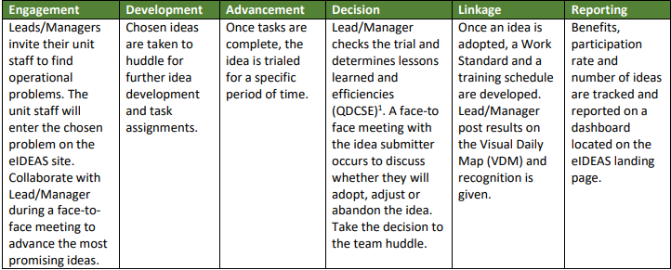

## **References**

N/A

## **Assumptions and Constraints**

Assumptions are future situations beyond the control of the project, whose outcomes influence the success of a project.]

[Provide a list of contractual or task level assumptions and/or constraints that are preconditions to preparation of the FRD. **Assumptions**

Examples of assumptions include: availability of a technical platform, legal changes and policy decisions.

### **Constraints**

Constraints are boundary conditions on how the system must be designed and constructed. Examples include: legal requirements, technical standards, strategic decisions.

* Constraints exist because of real business conditions. For example, a delivery date is a constraint only if there are real business consequences that will happen as a result of not meeting the date. If failing to have the subject application operational by the specified date places the organization in legal default, the date is a constraint.
* Preferences are arbitrary. For example, a date chosen arbitrarily is a preference. Preferences, if included in the FRD, should be noted as such.]

## **Document Overview**

The document is divided into three main sections, an Introduction shedding light about the purpose and scope of this document, followed by a Methodology describing in a simple way how the tool will work and ends up with a Functional Requirements section listing the tool parts and pieces.

# METHODOLOGY

TBA

# FUNCTIONAL REQUIREMENTS

## **Context** Diagram

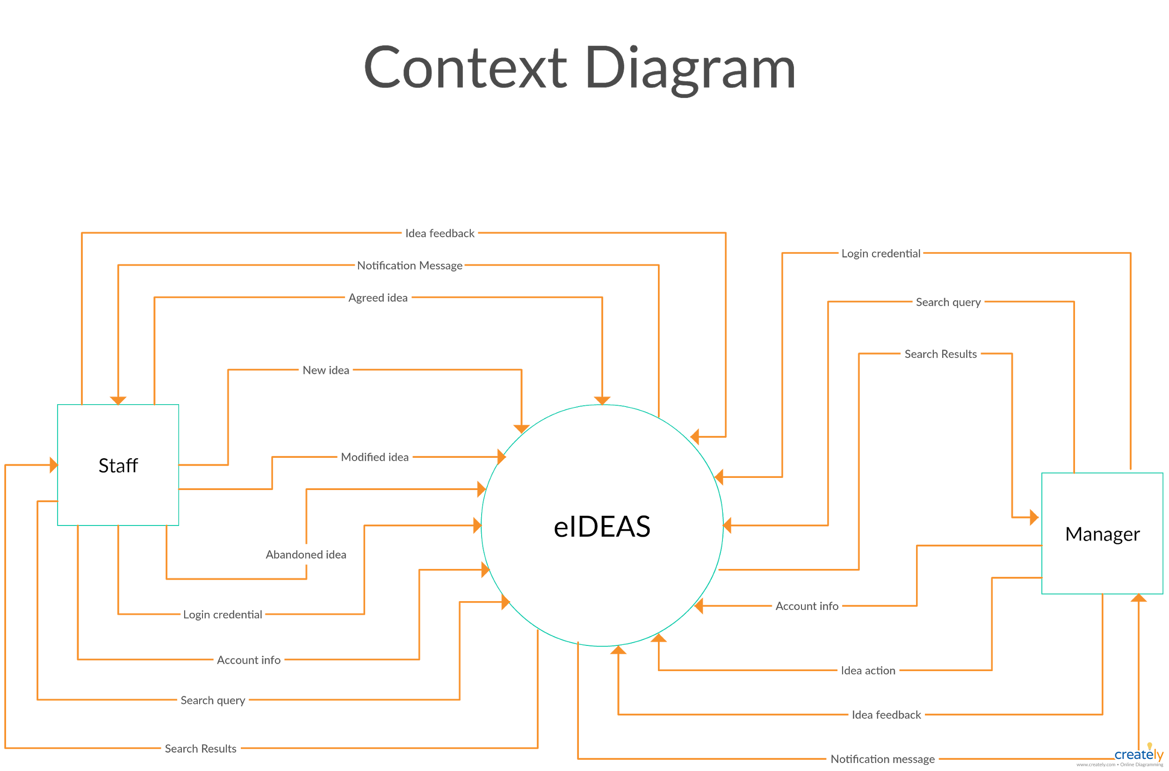

## **User Requirements**

* *Both Users*
  + 1. **Login**

Users must use their predefined username and password in order to login to the system. Users would be directed to the right dashboard based on their privileges.

* + 1. **Update Account**

At anytime, users should be able to update their profile information in addition to change their profile picture.

* + 1. **Search for Idea**

From the search bar, users can write a text query to filter the ideas results based on idea title, idea description, idea owner name.

* + 1. **Give Feedback**

From the “team’s ideas” page, users can write a feedback comment for any idea and post it on its thread.

* *Staff Member*
  + 1. **Add Idea**

Staff members can insert a new idea for their team. The new idea should contains title and description and be linked to its owner account. After submitting the idea, notification message should be sent to all staff members.

* + 1. **Modify Idea**

At anytime, Idea’s owner should be able to modify its description according to other members feedbacks outcomes.

* + 1. **Abandon Ideas**

In case idea got rejected or became not important anymore, idea’s owner should be able to delete it either from “Team’s ideas” or “My ideas” page.

* + 1. **Agree on Idea**

Staff members can agree/like certain idea from their “Team’s ideas” threads. Most agreed ideas should appear on the top of the page

* *Team Lead/Manager*
  + 1. **Approve idea**

Managers can check pending ideas and give approval to any of them. notification message should be sent to the idea owner informing him with the new changes. In case manager have not made any action to the pending ideas in five business days, an email digest should be sent to the manager asking him to take a action.

* + 1. **Reject idea**

Managers can access “Pending ideas” on their dashboard aad reject any of them. before submitting the action, the manager must write the rejection reasons in the shown textbox.

* + 1. **Park Idea**

Managers can park/archive ideas from “Pending ideas” page to give a later decision on it. At anytime, managers can access “Parked ideas” to give their final decision which would be Approve/Reject. notification messages should be sent whenever there's a change on the idea’s status.

## **Data Flow Diagrams**

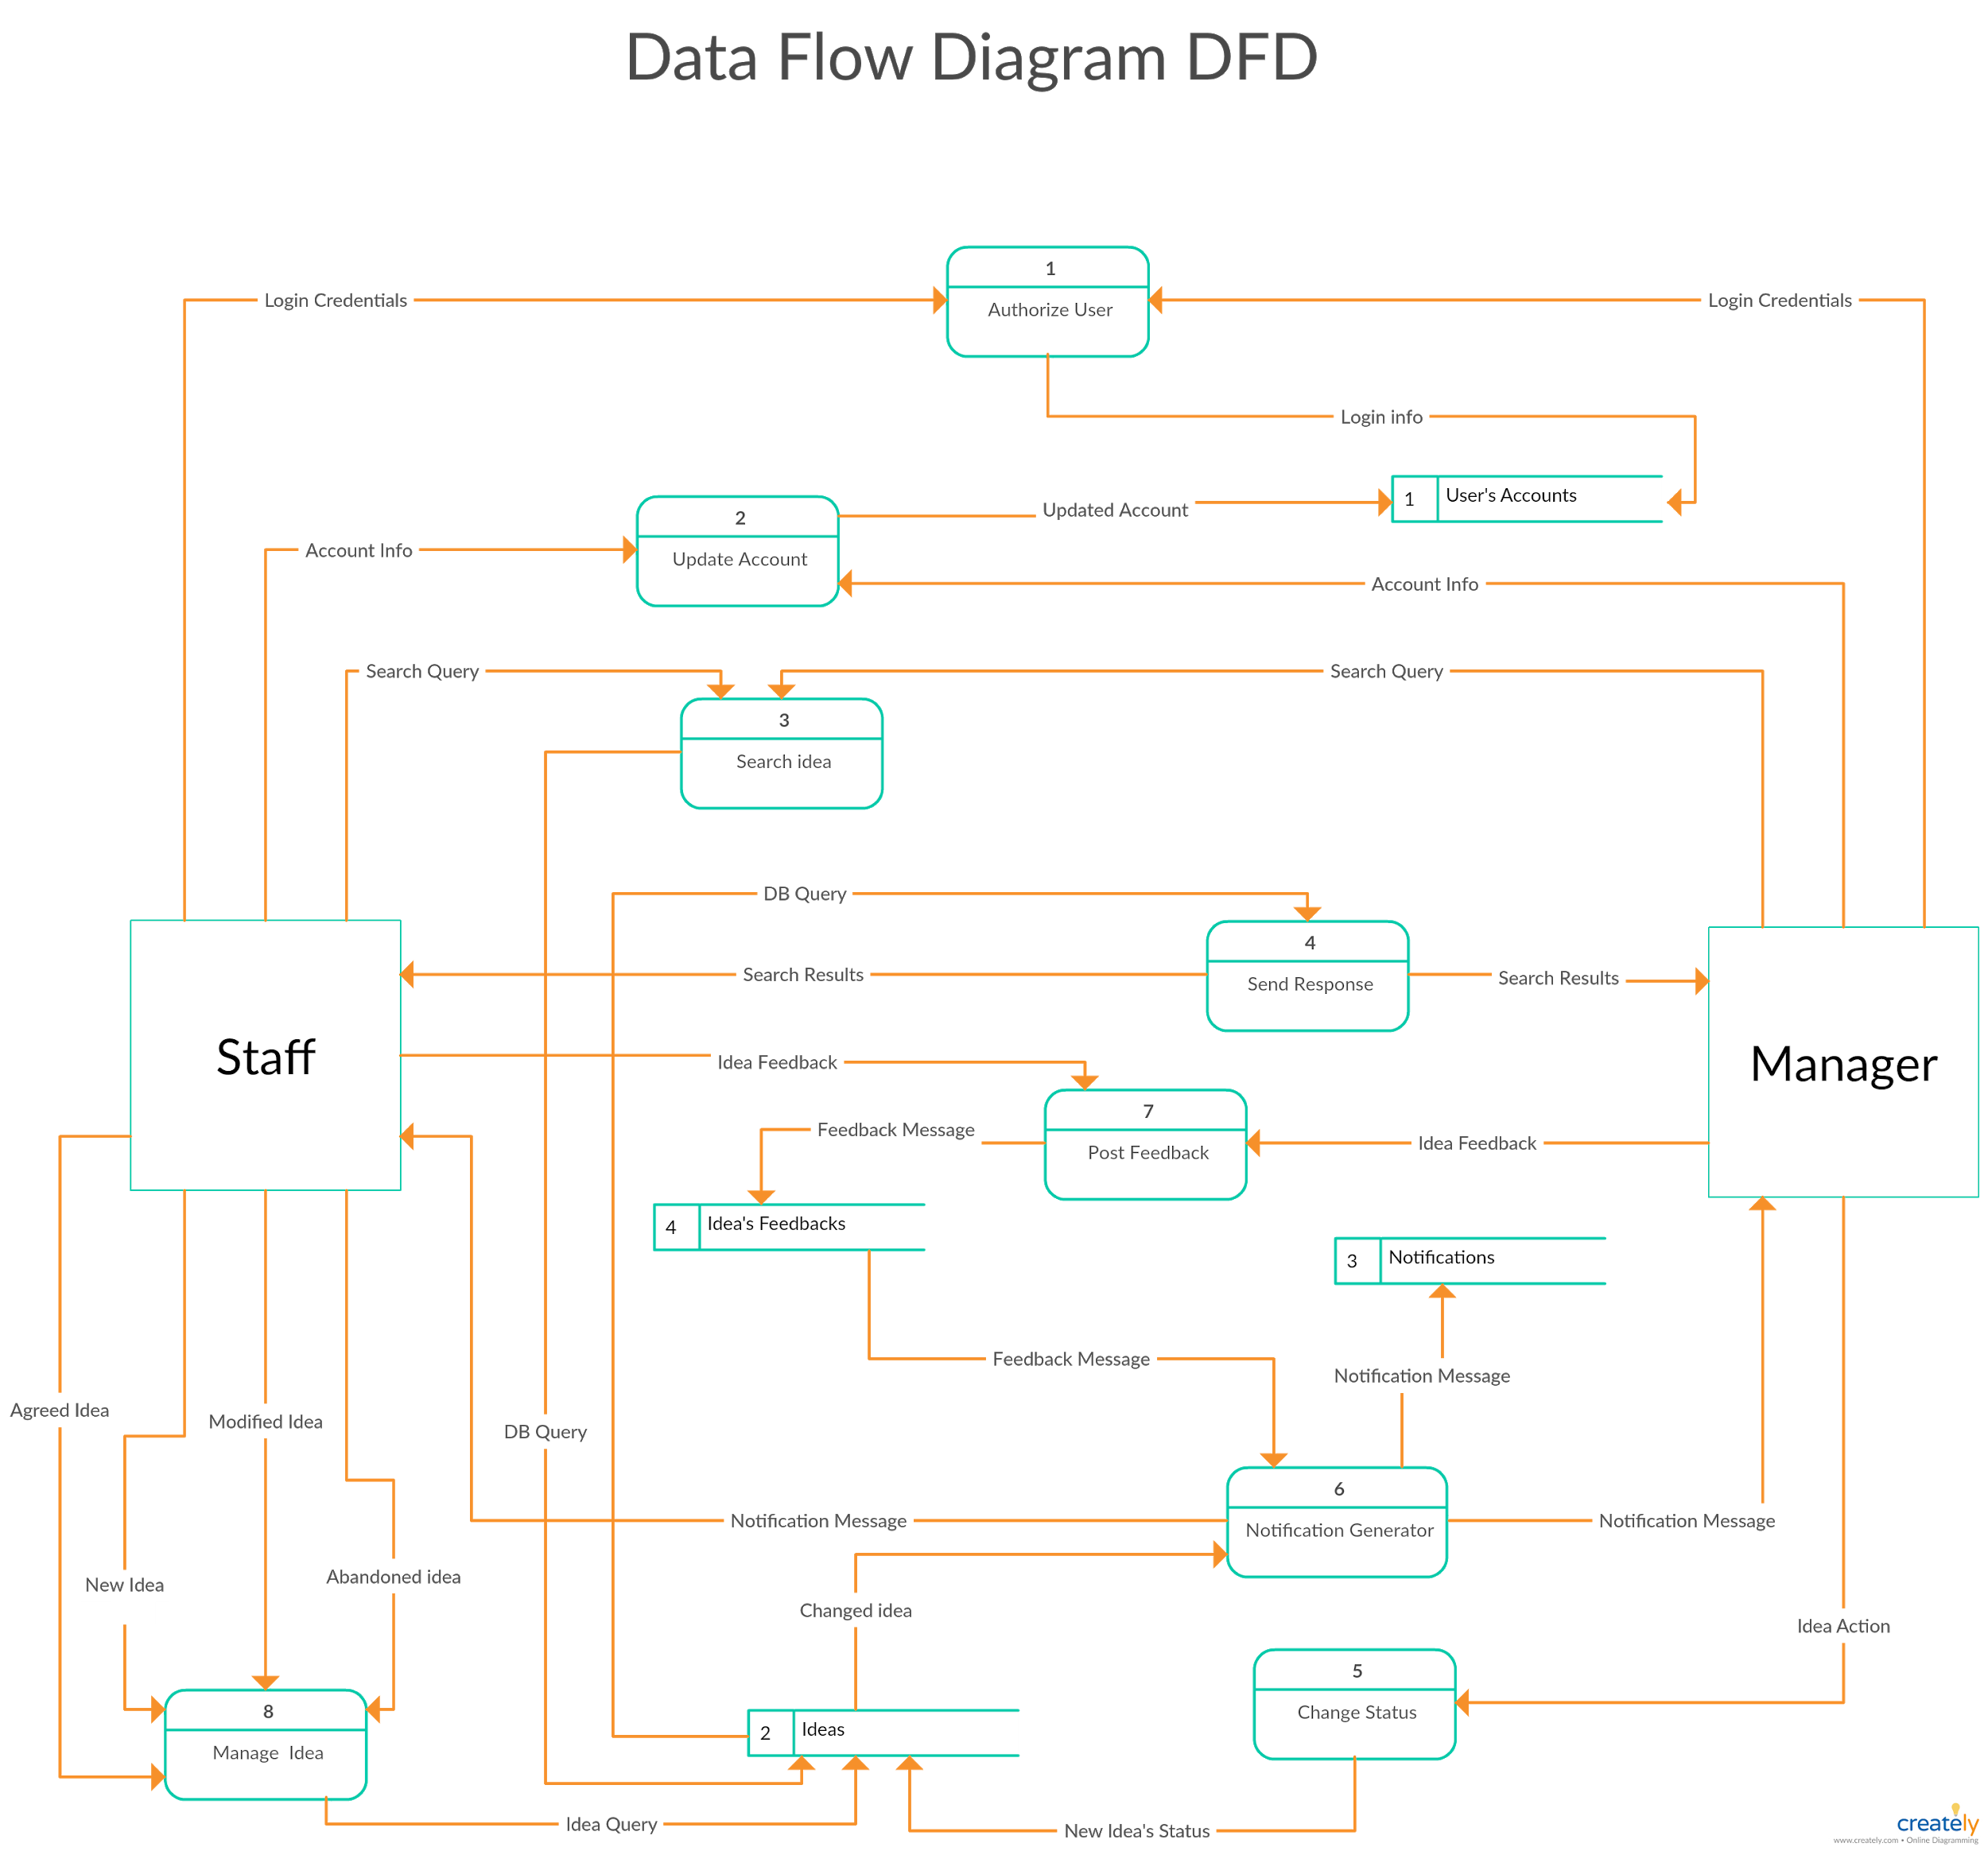

## **Logical Data Model/Data Dictionary**

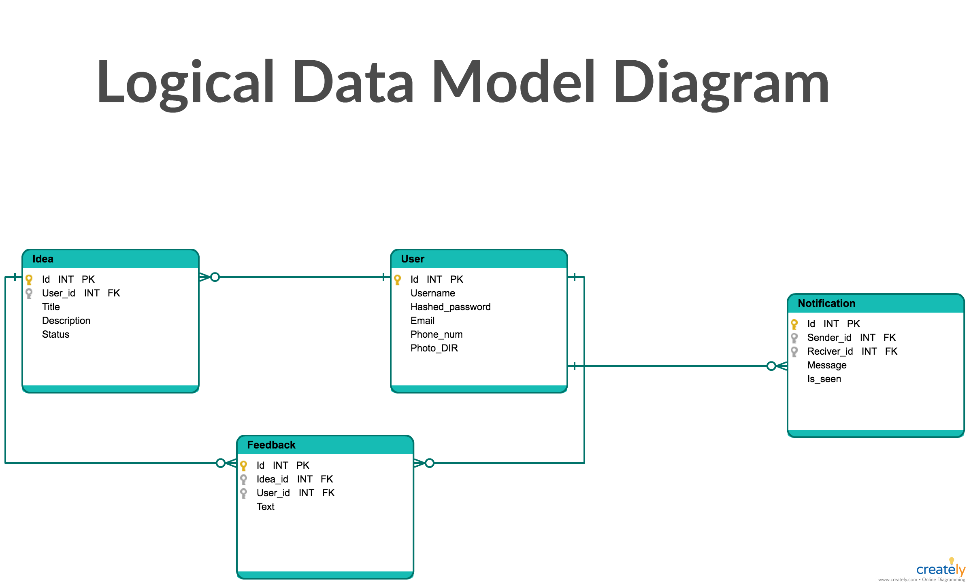

## Specification **Requirements**

* + 1. **Login**
* User open eIDEAS website portal then the login screen should appears.
* User has to enter his/her username and password in the required textbox fields, then user should press the “Login” button.
* eIDEAS send request with the user’s credential information to its database in order to validate them.
* If the given information is correct, eIDEAS will redirect user to the appropriate landing page/dashboard based on his privileges. otherwise, an error message should appear to the user asking him to repeat the process again.
  + 1. **Update Account**
* From the top left landing page, user will click on “Update account”
* A form page should appear to the user with all of his account information.
* User can update any textbox with his new information then click “Update” button. Also, user can click on “change profile picture” to upload a new image.
* eIDEAS will send a request with all of the updated information to its database.
* eIDEAS will send back a confirmation message to the user wither his information were updated or not.
  + 1. **Search for Idea**
* From the search bar above, user can write any search query then hit enter or the search button.
* eIDEAS will send a request with the query value to its database.
* DB query should be initiated to locate the matching content based on the idea title, ideas description and/or idea owner.
* eIDEAS should send back the query results and status message then ideas threads should be filtered based on those results.
  + 1. **Give Feedback**
* User can write a feedback comment on “Team’s ideas” page (in case staff member logged in) or in “Pending ideas” page (in case manager logged in).
* From the idea thread, user can write a feedback in the comments section then press on the “Send” button.
* eIDEAS will insert the feedback comment in its database and push it back to the other team members and managers.
* eIDEAS will send notification message to the idea submitter informing him/her with its details.

NOTE: The remaining specification are to be filled later.

# OTHER REQUIREMENTS

The web application (eIDEAS) shall be easy to use by all employees by decreasing the amount of scrolling the page for information and less number of clicks to achieve the desired output.

The web application shall allow multiple users within the scope(team) to enter their ideas without affecting the performance of the application

## **Interface Requirements**

The user interface will accept input from mice and keyboard only.

### **Hardware Interfaces**

A web server application will be able to serve any authenticated user over the internet via URL.

### **Software Interfaces**

The web application will interface with employee accounts (Active directory list) for authentication. Also, the web application will interface with a database (mysql or NoSql). NoSql provides search like queries to look for some words under idea column.

## **Data Conversion Requirements**

Data will be stored in database as plain text except large words can be replaced by one character.

## **Hardware/Software Requirements**

The web application will require following hardware and software needs.

2.0 GHz CPU speed, 1 GB of RAM, 64 GB of HDD.

Microsoft Windows 10 or later, Mac OS.

Internet explorer 11, Mozilla firefox, Google chrome or Safari internet browser.

## **Operational Requirements**

The web application will ask for dialogue prompt when data is not saved before proceeding to another screen.

When the user types in some predetermined values (e.g team name, staff name), the system will generate suggestion list to choose the rest of the value. Any disabled field will be provided with a description of the reason behind it.

### **Security and Privacy**

All authenticated user should protect their account information.

User must log out when accessing the information at public computer

The data may be lost or not readable when exposed under computer attack or viruses. The private information can be disclosed to unauthenticated users when not logged out on public computers.

### **Audit Trail**

Activities will not be recorded in primary version, but can be implemented in later versions of the web application.

### **Reliability**

Any damage to the application from power shutdown can result in loss of unsaved data Any physical damage to the hardware will result in loss of data since last backup.

### **Recoverability**

In the event of unavailability of the application, the web application should be back up running within 24 hours of the first reported time.

### **System Availability**

The web application will be available to user 22 hours (4 AM to 2AM next day) of each day of the week. System will be out of service for the rest for backup.

### **General Performance**

The response time for a query or update can vary substantially depending upon the volume of the data. User will be provided with a waiting screen to a maximum of 10 seconds and then error will be presented.

### **Data Retention**

The user data will be retained in the database for one year before backing up permanently on a storage device.